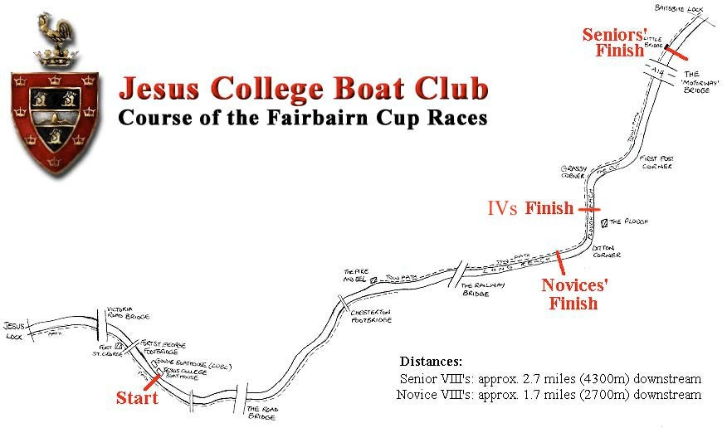Map of the Course

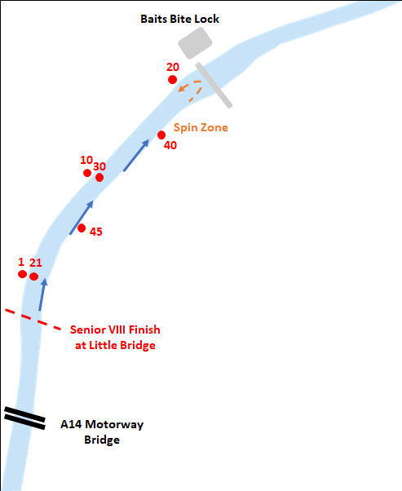Finish Marshalling Circulation Pattern for Seniors

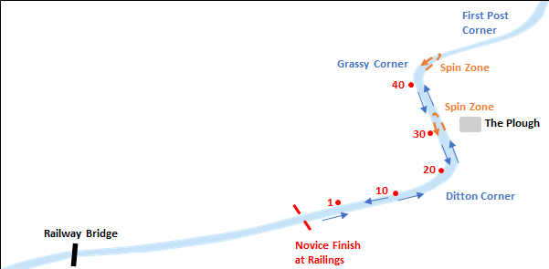Finish Marshalling Pattern for Novices

Start Marshalling Circulation Pattern

